Lecture 6 gr. 743 - Linear discrimination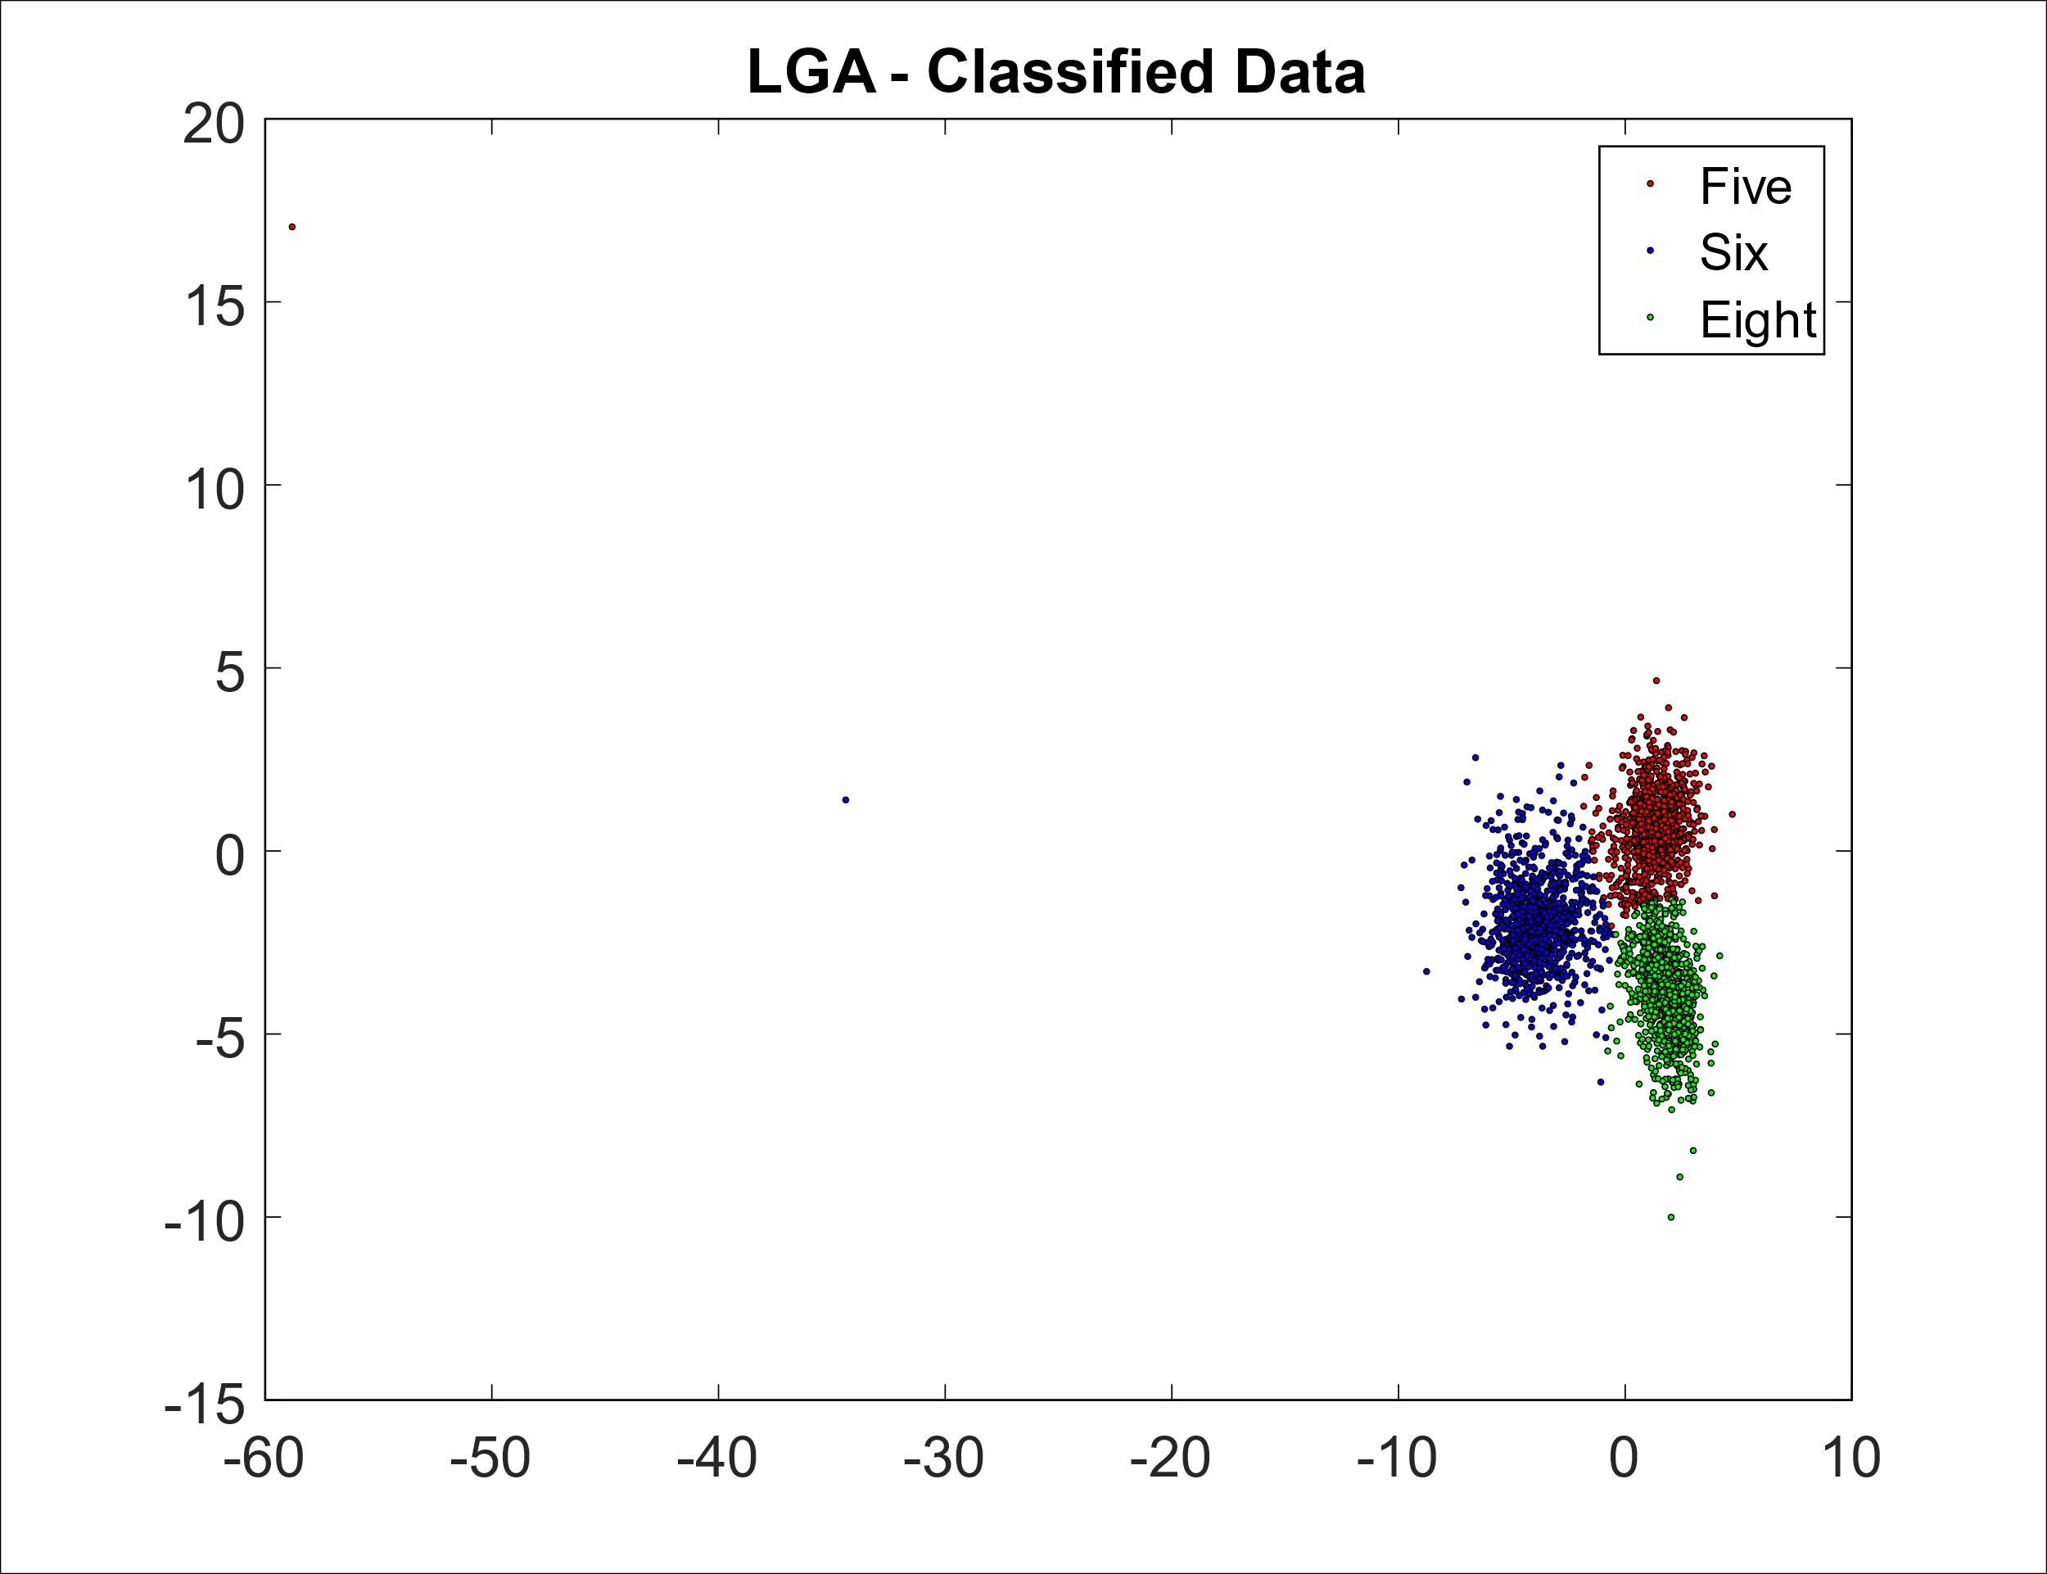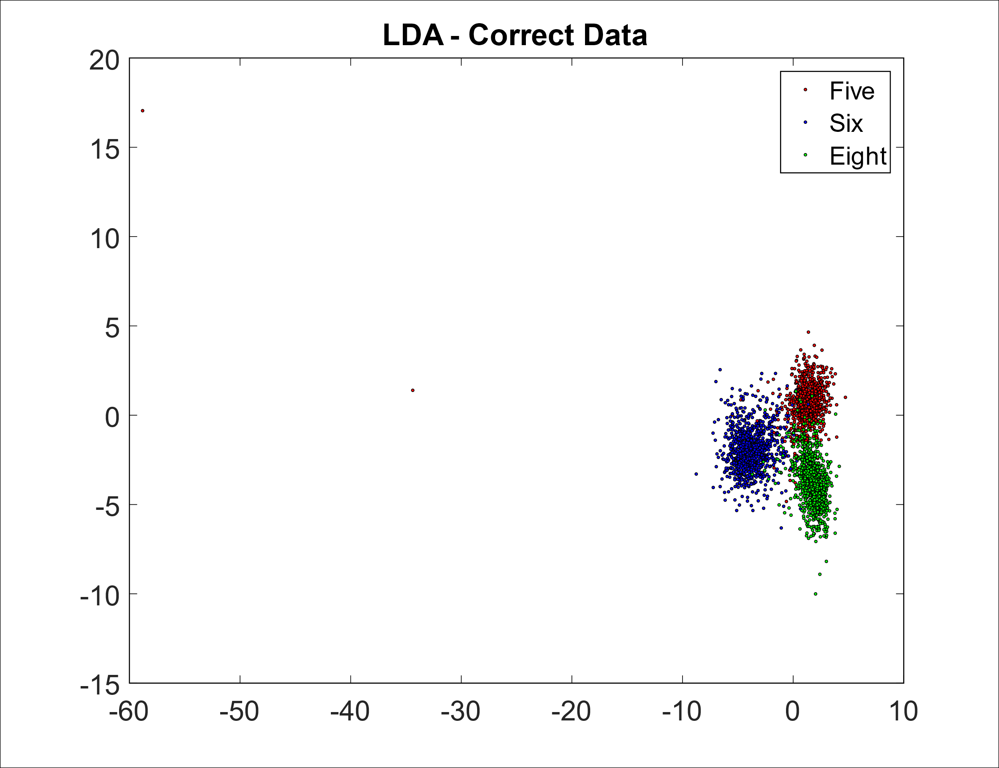

With the LDA we achieve a precision of which is a greater precision than obtained with PCA.